Menu do site

- Main
- Schedule
- Keynote Speakers
- Registration
- Submissions
- Committees
- Location
- Travel and Accomodation
- Contact

- Main:

The human brain is considered to be the most complex object in the known universe and the least understood organ in the human body. Neuroscientists with different backgrounds - medicine, psychology, electrical engineering, biomedical engineering, mechanical engineering, computer science, mathematics, physics and so on - aim to understand the brain. Furthermore, this research field has been receiving massive financial support, e.g.: the European Union has launched the Human Brain Project (HBP), budgeted in € 1-billion (HBP, 2015); and the US has launched the BRAIN (Brain Research through Advancing Innovative Neurotechnologies) initiative, budgeted in $100 million.

Latin American Workshop on Computational Neuroscience (LAWCN) has been giving its contribution since its first edition in 2017 (http://www.inf.ufrgs.br/lawcn/index.php?q=) providing a place, researches, and so on to discuss neuroscience. It is a biannual event, second edition in 2019 (), and …..

- Schedule
Deve basicamente mostrar um pdf que será enviado posteriormente

- Keynote Speakers

Ainda vou fazer mas gostei de como foi feito no I LAWCN (http://www.inf.ufrgs.br/lawcn/keynote.php?q=). Era uma página com basicamente uma foto de cada palestrante, nome, Short Bio, Title of the Talk e Abstract.
Para já coloca só isso: To be announced

- Registration
FEES:
UNTIL May 18th, 2021
Undergraduate Student: R$ 70,00
Graduate Student: R$ 150,00
Professionals: R$ 200,00

- Submissions

Prospective authors are invited to contribute to the conference by electronically submitting papers on the topics covered by the event (see complete list below).

- Best papers that are related to Computer Science (Computational Neuroscience) will be published as a book volume in Springer-Verlag Communications in Computer and Information Science (CCIS; ISSN 1865-0929) series (see book of LAWCN 2019 here <https://link.springer.com/book/10.1007/978-3-030-36636-0> and 2017 here< https://link.springer.com/book/10.1007/978-3-319-71011-2 >). CCIS is abstracted/indexed in DBLP, Google Scholar, EI-Compendex, Mathematical Reviews, SCImago, Scopus. CCIS volumes are also submitted for the inclusion in ISI Proceedings;



- Papers that are not related directly to Computer Science (Computational Neuroscience) will be published online in the II Latin-American Workshop on Computational Neuroscience Proceedings (with ISBN) and can be submitted in English, Portuguese, or Spanish (see proceedings of LAWCN 2018 here <https://www.lawcn.com.br/files/proceedingsfinal.pdf> and 2017 here< http://www.inf.ufrgs.br/lawcn/proceedings.php>).
- Papers will be evaluated based on their quality and significance of theoretical and practical contribution to Computational Neuroscience, Neuroengineering, Artificial Intelligence, and Neuroscience in general;
- All papers (Short or Full) must be in PDF format and include abstract, figures, tables and references in the minimum/maximum number of pages (according to the category desired);
- Papers can be submitted in four categories (see image bellow):
  - Short paper not related directly to Computer Science (Computational Neuroscience):
    - Length: between 3 and 8 pages
    - Languages: English, Spanish, and Portuguese
  - Short paper related to Computer Science (Computational Neuroscience):
    - Length: between 6 and 9 pages
    - Language: English only
  - Full paper not related directly to Computer Science (Computational Neuroscience):
    - Length: between 10 and 20 pages
    - Languages: English, Spanish, and Portuguese
  - Full paper related to Computer Science (Computational Neuroscience):
    - Length: between 10 and 20 pages
    - Language: English only

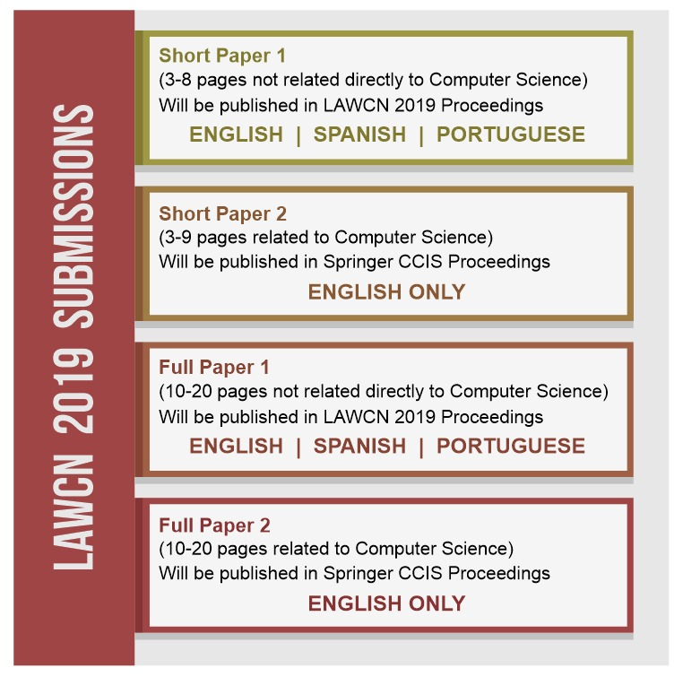

- Papers can be submitted in English, Portuguese or Spanish, but only the best papers, in English, and directly related to Computer Science will be published in CCIS;
- Papers should be submitted exclusively through the conference submission system, linked below;
- At least one author must register, pay the registration fee, and present orally the accepted paper in order for the manuscript to be included in the workshop proceedings / CCIS volume. If more than one paper per first author is accepted, there will be an extra registration fee.
- One of the authors must sign and attach the disclosure form if the paper is accepted;
- It is encouraged that authors own an identification from ORCID to be included in the manuscript main body. You can register at ORCID here<www.orcid.org>;
- All authors should consult and follow Springer’s author’s guidelines < ftp://ftp.springernature.com/cs-proceeding/svproc/guidelines/Springer_Guidelines_for_Authors_of_Proceedings.pdf > and use their proceedings templates, either for LaTeX <arquivo llncs2e.zip > or for MSWord (2003 and older <arquivo Microsoft+Word+2003+Proceedings+Templates.zip > / 2010 and newer < splnproc1703.zip >), for the preparation of their papers;
- All authors should read and abide to Springer’s ethical guidelines < https://www.springer.com/gp/authors-editors/journal-author/journal-author-helpdesk/before-you-start/before-you-start/1330#c14214 >;
- A LaTeX template for the event can be found within Overleaf tool, but submission directly from this system is not available.

<<BOTÃO DO EASY CHAIR>>

GUIDELINES FOR AUTHORS: ABSTRACTS

- Abstracts will be published online in the III Latin-American Workshop on Computational Neuroscience Proceedings (with ISBN).
- Abstracts will be evaluated based on their quality and significance of the theoretical and practical contribution to Computational Neuroscience, Neuroengineering, Artificial Intelligence, and Neuroscience in general. Ongoing and incomplete work is perfectly acceptable for abstracts.
- Authors should strictly observe the following guidelines:
  - Abstracts must contain the following sections (in order): Full title, List of authors, Affiliations, Introduction (with objectives), Methods, Results, Discussion, and Acknowledgments (for funding agencies and others).
  - References should be avoided. If mandatory, they should be kept to a very minimum and should be inserted in short format (without title) in the end of the abstract.
  - Texts must contain a maximum of 600 words, including all sections.
  - Texts must be a single page in length.
  - Authors are allowed to include one figure OR one table only if it can fit in a single page with the main text, placed after Discussion section and before Acknowledgments.
  - Font size, margins, line separation, and other formatting parameters are described in the abstract model found here <linkar arquivo do abstract aqui> and must be observed strictly.
- Authors must submit their abstracts exclusively via e-mail, to E-MAIL@gmail.com. DO NOT USE the conference paper submission system, linked in the previous session;
- Authors may identify their e-mail with the following subject: “Abstract submission: <AUTHOR SURNAME>, <AUTHOR INITIALS> - <INSTITUTION>”. For example: “Abstract submission: McCulloch, W. – Univ. of Chicago”;
- At least one author must register, pay the registration fee, and present the accepted abstract as poster in the conference (time and place to be defined) in order for the work to be included in the workshop proceedings. If more than one abstract per the first author is accepted, there will be an extra registration fee.
- Abstracts with too many grammatical errors, typos, or formatting problems will be rejected.
- Authors will also be requested to give a 60 to 90-seconds oral presentation (pitch) to the full audience, as a call to his / her poster.
- Abstract, poster, and pitch must be in the same language.

IMPORTANT DATES

- Paper submission deadline: April 30, 2021(via Easychair)
- Notification of acceptance: July 30, 2021
- Camera-ready papers: September 17, 2021
- Workshop: November 10-12, 2021

Topics

Computational Neuroscience
- Biophysically realistic models
- Single-neuron modeling
- Models of brain networks and circuits
- Sensory processing
- Development, axonal patterning, and guidance
- Memory and synaptic plasticity
- Consciousness
- Computational clinical neuroscience
- Neuroinformatics
- Educational issues
- Neural coding
- Neural statistics
- Dendritic computation
- Neural basis of persistent activity
- Nonlinear receptive field mapping
- Representations of time and sequence
- Reward systems, decision-making simulation
- Synaptic plasticity
- Population coding
- Spiking neural networks and applications
- Complex systems and network conectivity
- Neural Information Theory
- Neurocomputational systems
Neuroscience
- Sensory processing
- Network dynamics
- Reinforcement learning
- Motivation and decision making
- Statistical approaches in neuroscience
- Systems neuroscience
- Learning and memory
- Attention and arousal
- Sensory-motor integration
- Learning in networks
- Educational issues
Neuroengineering
- Large-scale recordings
- Neural signal processing
- Neuromodulation
- Neuroprosthetics
- Robotics
- Humanoid robots
- Robots in health
- Robots for elderly people
- Sensoring in robotics
- Fusion of sensors
- Hardware implementations in neuroscience
- Software implementations in neuroscience
- Brain Computer Interfaces: design and applications
- Educational issues
Artificial Intelligence and related topics
- Artificial Intelligence
- Techniques in neuroscience
- Bioinformatics
- Clustering and applications
- Computer vision, cognitive and humanoid vision
- Databases, data mining, intelligent data analysis, knowledge-based systems and linguistic tools
- Data visualization and applications
- Deep Learning
- Statistical pattern recognition / document processing and recognition
- Fuzzy and hybrid techniques
- Geometric algebra application in perception action
- High performance computing for pattern recognition
- Image coding, processing and analysis
- Kernel machines
- Mathematical theory of computational neuroscience
- Natural language processing and recognition
- Neural Networks
- Parallel and distributed applications for computational neuroscience
- Robotics and humanoids shape and texture analysis
- Signal processing and analysis
- Spatiotemporal analysis
- Educational issues

- Committees
Vai ser igual os de LAWCN de 2017 e 2019 (https://www.lawcn.com.br/comittee.html). Deverá ter 4 tabelas: Conference Chair, Organization, Executing team and Program Committee. Todas as tabelas terão 3 colunas para nome, Afiliação (universidade) e País.

- Location
Deixa em branco que depois envio as informações sobre São Luís como foto e tudo.

- Travel and Accomodation
Deixa em branco que depois envio as informações.

- Contact
Deixa em branco que depois envio as informações.

